How to update the firmware for the KA17
注意：在为KA17升级固件之前，请拔掉电脑上USB接口的其他解码器！
Note: Before upgrading the firmware for KA17, please unplug other decoders from the USB interface on the computer!

KA17 XMOS V1.49固件升级内容：
1、新增连接电脑解码，电脑端的音量可调并记忆
2、新增手机USB独占模式播放音量可调
3、新增插入侧口USB的弹窗提示
4、修复在Fiio Control App或本机切换EQ不能实时跟随问题
5、修复在Fiio Control App调节EQ自定义3数据保存错乱问题
6、修改EQ切换逻辑，EQ为OFF时支持MQA，打开EQ不支持MQA和DSD曲目
7、修改滤波器命名
8、优化UI界面
9、其它性能优化
KA17 XMOS V1.49 firmware upgrade content:
1. Added computer decoding, allowing volume adjustment and memory on the computer.
2. Added volume adjustment for playing in Exclusive USB Audio Access Mode on mobile phones.
3. Added a pop-up prompt for inserting USB into the side port.
4. Fixed the issue where switching EQ in Fiio Control App or on the device does not follow in real-time.
5. Fixed the issue of incorrect data saving when self-defining EQ 3 in Fiio Control App.
6. Modified EQ switching logic: MQA is supported when EQ is off; while MQA and DSD tracks are not supported when EQ is on.
7. Renamed filters.
8. Optimized UI interface.
9. Miscellaneous improvements in performances.

KA17 XMOS V1.49固件升级教程：
KA17 XMOS V1.49 firmware upgrade tutorial:
1、在Windows电脑中安装Fiio USB DAC驱动V5.62。如果您的Windows电脑中已经安装了其他版本的Fiio USB DAC驱动，请卸载掉，之后再安装V5.62版本的驱动。安装完成V5.62驱动后，建议重启电脑。如果您已经安装了Fiio USB DAC驱动V5.62，请忽略此步骤。
1. Install Fiio USB DAC driver V5.62 on your Windows computer. If other versions of the Fiio USB DAC driver are already installed on your Windows computer, please uninstall it and then install the V5.62 driver version. After installing the V5.62 driver, it is recommended to restart the computer. If you have already installed Fiio USB DAC driver V5.62, please ignore this step.

2、将KA17与Windows电脑连接。为了避免因电脑USB接口供电不足导致升级失败，尽量选择电脑后面板的USB接口进行升级。
2. Connect KA17 to the Windows computer. In order to avoid upgrade failure due to insufficient power supply of the computer USB interface, try to choose the USB interface on the back panel of the computer for upgrade.

3、升级固件前请把KA17的D.MODE开关切换为OFF状态，USB模式切换为U2.0，不要播放音乐。在升级固件的时候，不要晃动USB数据线，以免升级失败。
3. Before upgrading the firmware, please switch the D.MODE switch of KA17 to OFF state, switch the USB mode to U2.0, and do not play music. When upgrading firmware, do not shake the USB data cable to avoid upgrade failure.

4、升级固件前，请将KA17菜单设置中的“MQA”选项选择为“打开”状态；如果该固件没有“MQA”选项，请将菜单设置中的“EQ”选项选择为“关闭”状态。
4. Before upgrading the firmware, please select the "MQA" option in the KA17 menu settings to "ON"; if the firmware does not have an "MQA" option, please select the "EQ" option in the menu settings to "OFF".

5、双击“FiiO_Dfu_KA17”打开烧录工具，选择“Fiio_KA17_xmos_V149_dfu_V99.bin”，之后点击Start进行升级。
5. Double-click "FiiO_Dfu_KA17" to open the burning tool, select "Fiio_KA17_xmos_V149_dfu_V99.bin", and then click Start to upgrade.
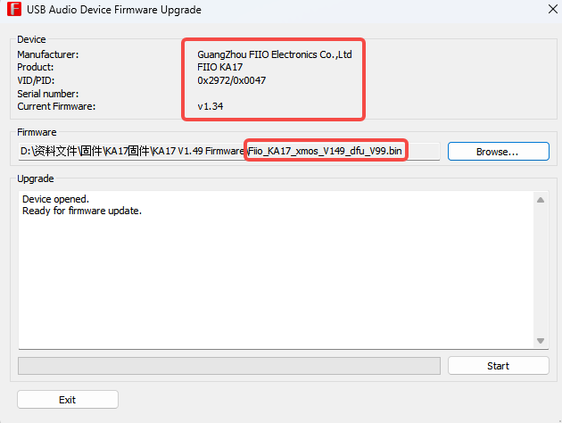

6、当出现“Firmware upgrade finished successfully”时，可以将KA17拔下，再连接USB线，此时KA17的屏幕会出现“升级中，预计需三分钟，请勿拔USB”的升级弹窗，请耐心等待升级完成。当升级完成后，屏幕会出现“升级完成”的字样，即表示KA17固件升级成功。
6. When "Firmware upgrade finished successfully" appears, you can unplug KA17 and then connect the USB cable. At this time, the upgrade pop-up window "Upgrading in progress, estimated to take three minutes, please do not unplug USB" will appear on the screen of KA17. Wait patiently for the upgrade to complete. When the upgrade is completed, the words "Upgrade Complete" will appear on the screen, indicating that the KA17 firmware upgrade is successful.

7、固件升级成功后，可以重新拔插KA17，之后可以在Fiio控制面板中看到固件版本号。
7. After the firmware upgrade is successful, you can re-plug the KA17, and then you can see the firmware version number in the Fiio control panel.
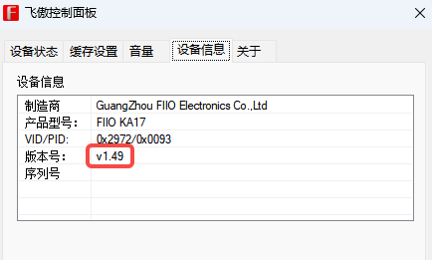

注意：如遇到KA17插入USB升级时弹出“升级失败”弹窗时，可以按一下KA17的关闭/点亮屏幕的按键，KA17会正常进入主界面，这时不要拔掉USB数据线，把升级工具重新打开升级一遍，升级完再拔插一下USB等待KA17升级完成。
Note: If the "Upgrade failed" pop-up window pops up when KA17 is plugged into USB for upgrade, you can press the close/light screen button of KA17. KA17 will enter the main interface normally. At this time, do not unplug the USB data cable and put the upgrade in. Re-open the tool and upgrade again. After the upgrade, unplug and plug in the USB and wait for the KA17 upgrade to complete.

